Job title: Personal Advisor | Service area: Children Help and Protection
Post number: | Division: Children and Families
Grade: 7 | Section/team: Care Leavers
Overall purpose of job:

Design and deliver effective Pathway Planning and intervention in collaboration with care experienced young people, that supports young people to achieve their ambitions and aspirations and live successfully within our community.

Contribute to the provision of an innovative and effective range of accommodation services for young people who are homeless or have left care and are eligible for services under the Children Act 1989

Work in partnership with young people, their families and colleagues, to assess needs, decide on eligibility, plan interventions to enable young people to return to their families or into suitable accommodation with a package of support.

Post holders will be expected to be flexible in undertaking the duties and responsibilities attached to their post and may be asked to perform other duties, which reasonably correspond to the general character of the post and are commensurate with its level of responsibility.
Main responsibilities:

- Assess young people’s eligibility for the service and identify and assess the needs of young people requiring guidance / accommodation / support on housing and related issues through effective Pathway Planning, including developing, implementing and reviewing dynamic outcome focussed planning in collaboration with young people.
- Engage and develop appropriate relationships with young people assessed as needing the service through effective relational practice.

- Provide support, advice and assistance to enable young people to return to their families wherever possible.

- Act as designated Personal Advisor to named Care Leavers ensuring compliance with statutory requirements under the Children (Leaving Care) Act 2000, Planning Transition to Adulthood for Care Leavers 2010 and Supported Accommodation Regulations (2023) in respect of in house supported accommodation and supported lodgings.

- Support young people in identifying and developing their support networks to enable them to live independently.

- Responsible for responding to and supporting young people facing crisis and emergency situations as a main source of support.

- Prepare, manage and review young people’s Pathway Plans in line with statutory and local requirements and facilitate access to other support agencies as may be identified in the course of the assessment and Pathway Planning process including seeking accommodation and support from in house support accommodation, partners in Housing Advice Service and external providers. Compile, deliver and monitor creative plans for young people, in conjunction with the Pathway Plan, ensuring that the plan is needs led.

- Provide and commission support to young people, including assistance in, budgeting, independent living skills, arranging access to professional services, claiming benefits, maintaining the safety of their dwelling.

- Compile reports for plans, reviews and other meetings, including Pathway Planning meetings, reviews and other meetings as appropriate. Including completing routine administrative tasks i.e. updating case records, chronologies, etc.

- To organise, chair and attend relevant meetings for young people, including risk management meetings, review meetings, case conferences, amongst others

- Help young people to access education, training and employment and be aspirational about their future opportunities.

- Work in partnership with other agencies and professionals to address the complex needs of young people.

- Liaise with Housing Advice Service and other accommodation providers to mediate and deal with behavioural difficulties or particular vulnerabilities shown by young people.

- Communicate with staff within the service within the agreed service structure.

- Ensure that the service meets statutory requirements including the provision of services, meeting timescales and compliance with regulatory frameworks.

- Oversee the young person’s day-to-day financial budget, in line with the Pathway Plan, including the administering of finances in line with the Children (Leaving Care) Act 2000 and Planning Transition to Adulthood for Care Leavers 2010.

Knowledge, skills and experience:

Experience of working with care experienced young people to bring about positive change
Knowledge and experience of developing, implementing and reviewing dynamic outcome focussed planning in collaboration with young people.

Good communication skills both oral and written.

Developing understanding of basic entitlements for young people, e.g. benefits, housing, tenancies.

Basic knowledge of Child Protection Children in need and Vulnerable Adults procedures.

In depth knowledge of Health and Safety regulations when applied to the quality and suitability of accommodation.

ICT skills
The ability to work as part of a team and to your own initiative, under minimum supervision Ability to organise and prioritise your own workload.
Developed knowledge of the issues faced by young people who are homeless or leaving care.

Ability to make decisions in the absence of a senior within an agreed framework.

Ability to maintain accurate records and maintenance of confidentiality, including sound awareness of GDPR regulations.

Knowledge of relevant legislation, including The Children (Leaving Care) Act(2000), Planning Transition to Adulthood for Care Leavers (2010), Supported Accommodations Regulations (2023) Directorate policies and procedures, service standards, local and national guidance.

Knowledge of child development and working with young people.

Creativity and innovation:
Adopt communication & engagement skills individually to young people, according to their level of need and understanding.

Use creative strategies to engage young people in activities that are part of a tenancy support programme.
Produce creative plans for the provision of accommodation support.

Develop effective and flexible support programmes which enable clients to achieve independence

Contribute to the development of systems and procedures in support of young people’s accommodation
Contribute to the service strategy, ensuring the full involvement of service users Assess young people presenting as homeless and make appropriate recommendations Take lead in negotiating with accommodation providers where required
Use interpersonal skills, empathy and negotiation skills, in order to match suitable accommodation providers with young people homeless or leaving care, according to assessed needs, wishes and feelings and suitability.

Contribute to the management of highly complex cases and difficult to reach young people

Take lead in initiatives relating to the Children (Leaving Care) Act 2000 and Planning Transition to Adulthood for Care Leavers 2010

Contacts and relationships:
Elected members: Enquiries/complaints from public, local authority initiatives, such as democracy week, teenagers to work, consultation info.

Benefit Offices: Advocate for Young People with claim queries, liaise & assist with claims related to accommodation issues.

Housing: Enquiries about housing availability & allocations, ensuring Young People are kept on housing lists whenever appropriate, liaison regarding tenancy support packages. Specialist Services Teams: Liaise regarding cases, Child in Need or Safeguarding issues, information gathering, meetings, sharing of information in line with information sharing policy.
Children’s Homes: Meetings relevant to Young People, staffing issues, information gathering, liaison regarding cases.

Mental Health Services: Obtaining information, giving referrals, asking for advice, joint working on matters relating to accommodation

Health: Liaising with GPs/other supporting Young People to attend appointments, transport, on matters relating to accommodation

Custodial institutions: Occasional visiting of Young People, ongoing support, contributing to plans for release.
Youth Justice Partnership/Probation: liaising regarding cases, information gathering, contributing to Pre-Sentencing Reports (PSRs) & bail/remand support, in accommodation matters.

Solicitors: obtaining appropriate advice & advocacy for Young People in relation to accommodation issues and tenancy disputes
Careers Advisors/EIO: Liaison in order to stabilise young people in accommodation prior to encouraging them into employment/education, training, higher education, new start, learning gateway.

Housing Providers: Arranging accommodation, bonds, rents, assisting with issues arising regarding tenancy or benefits.
Police/courts: supporting Young People through these systems, supporting to attend appointments, acting as appropriate adult if arrested, advocacy
Senior Management Team: Deputise for Senior members of the team, as appropriate.

Decision making:

Day-to-day decisions in relation to core tasks and case work.
Assess and make recommendations to managers on the appropriateness of properties in line with Health and Safety Regulations

Responsibility for prioritising own case worker and assisting colleagues in prioritising their workload.

Analysis and decision-making following assessments of young people, and implementation of outcome focussed planning

Deputise for Senior members of the team where required.

Represent the service in local forums and partnership arena, making decisions regarding service and resource allocation and deployment

Plan and review services to meet the identified accommodation needs of young people. Decide on the responses to emergency and crisis situations for young people.
Provide guidance and decisions on Health and Safety issues, benefits and related entitlements for young people.

Financial and Resource issues associated with accommodating young people who have left care or present as homeless, and the application of the financial policy for care experienced young people.

Administer financial arrangements as specified in The Children (Leaving Care) act 2000 and Planning Transition to Adulthood for Care Leavers 2010

Responsibility for resources:

Financial resources:

Supporting young people to maintain their accommodation through payments for accommodation, rent and support provided by landlords.

Responsible for applying the Financial Policy within Pathway Planning, ensuring that this is linked to promoting outcomes and aspirations for young people. Out of the office for more than 50% of time.

WORK ENVIRONMENT
Work demands:

Post holder will work alone with young people which will be challenging and complex.

Contributes to the management of highly complex cases and hard to reach young people.
Requires management of complex & conflicting priorities, eg: planned work (casework appointments, reviews) - crisis work (emergencies, duty) including working at short notice, including evenings and weekends, as required.
Communicate and build relationships with service users who may present complex and sometimes challenging behaviours which can be unpredictable

Physical demands:

Normal physical effort.

Working conditions:

Working in the community and within service user’s homes, in variable conditions and in Office base. Working unsocial hours

Post holder may work alone with young people.

Work context:

Potential hazards, challenging behaviour, infection, infestation (scabies, lice, Hepatitis B, C, etc). Addressed through risk assessment, health and safety procedures, lone worker policy, immunisation.

Position in organisation:

Indicate how many staff the post is directly accountable for: 0

Are posts in more than one location? No
Is this at the same site?
Are the posts managed highly mobile? No

Is the supervision/management shared with another post in the structure?
Yes/No

Please indicate which post(s) _______________________________________________

You must provide an organisation chart that shows where the job sits within the structure. This should be a simple diagram but with enough detail to put the job into context, i.e. the post holder may manage different groups of staff undertaking different tasks. The chart must show the job in question, the job to which it reports, those jobs which report alongside it and subordinate posts.
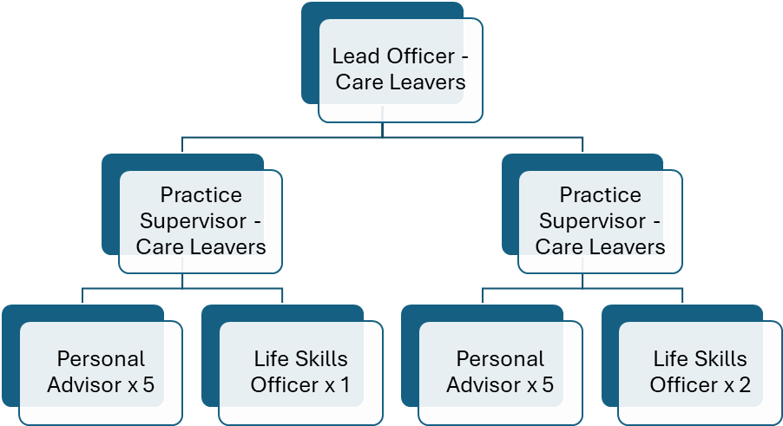

Job Description Version Control
Date evaluated
Date updated
Updated by (manager name)
Checked by (HR name)

ESSENTIAL CRITERIA | ASSESSED THROUGH:
Knowledge, Skills and Experience | Application form
- Knowledge and experience of developing, implementing and reviewing dynamic outcome focussed planning in collaboration with young people
- Experience of multi-agency working
- Good communication skills -written
- Developing understanding of basic entitlements for young people e.g. benefits, housing, tenancies
- Basic knowledge of Child Protection, Children In Need and Vulnerable Adults procedures
- Developed knowledge of the issues faced by young people who are homeless or leaving care
- Ability to make decisions in the absence of a senior within an agreed framework
- Ability to maintain accurate records and maintenance of confidentiality, including sound awareness of GDPR regulations
- Knowledge of relevant legislation, including the Children (Leaving Care) Act (2000), Planning Transition to Adulthood for Care Leavers 2010 and Supported Accommodation Regulations (2023) in respect of in house supported accommodation and supported lodgings. As well as knowledge of directorate policies and procedures, service standards, local and national guidance
- In depth knowledge of Health and Safety regulations when applied to the quality and suitability of accommodation
- Good ICT skills

Knowledge, Skills and Experience | Interview
- The ability to work as part of a team and to your own initiative, under minimum supervision
- Ability to organise and prioritise your own workload
- Good communication skills -Oral

Education, Training and Qualifications | Original documents
Working Arrangements | Interview
- Ability to transport yourself throughout North Lincolnshire
- Working unsociable hours on occasions

DESIRABLE CRITERIA | ASSESSED THROUGH:
Knowledge, Skills and Experience | Application form (follow up at interview)
- Experience of working with care experienced young people to bring about positive change.
Knowledge, Skills and Experience | Interview
Education, Training and Qualifications | Original documents
- Any relevant qualifications or training undertaken.
Working Arrangements | Interview
- Ability to transport yourself throughout North Lincolnshire
- Working unsociable hours on occasions

THE POST IS SUBJECT TO:
Disclosure of convictions under the Rehabilitation of Offenders (Exemption) Act 1974
Yes | P | No | ☐
Political restriction
Yes | ☐ | No
The ability to speak fluent English under the Immigration Act 2016
Yes |  | No | ☐

- Version Control
Author | HR Policy Team
Status | V0.1
Date approved | 19 September 2012
Last updated | 14 April 2025

